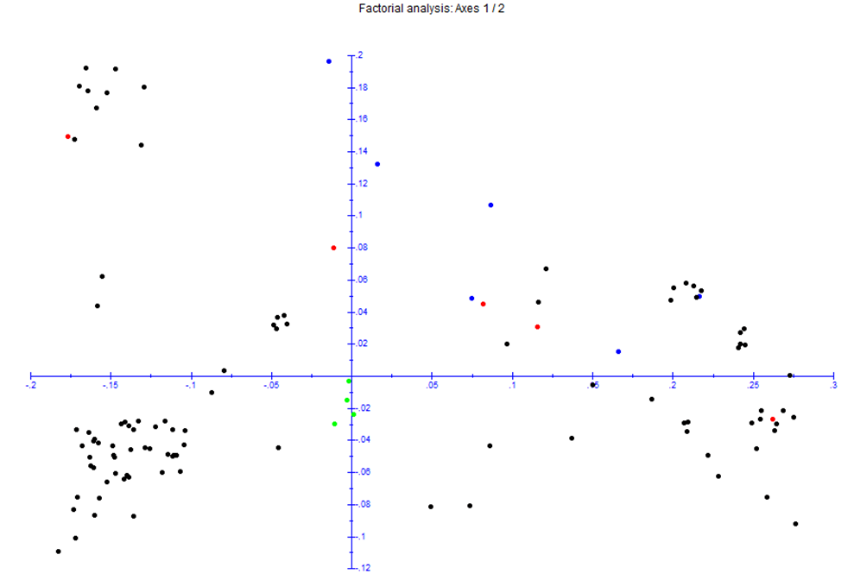

Factorial plot of the cowpea accessions.

